Wellbeing Ideas and Resources for Families in Lockdown

Jenny Mosley The Five Wells of Wellbeing

Jenny Mosley has developed the “Five Wells of Wellbeing” with activities for children.

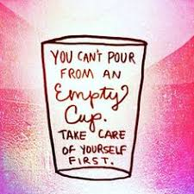
In the absence of a normal routine, developing a routine to include each of these “wells” might be helpful to our children’s wellbeing in this extraordinary time. I suspect the same is true for the rest of us.

Intellectual well: Keep reading, keep learning
There is so much online learning available. Children can keep up to date with learning online and it might be an opportunity for adults to up-skill or learn something new from online training too.

Emotional well: have fun, play, enjoy time with loved ones.
In our busy lives, how often do we take the time to be fully present with loved ones? Social distancing will ironically give us more time to spend with families at home and to keep in touch with others via phone/IT.

Spiritual well: time for contemplation.
Keep a journal; meditate; read; connect with others and seek understanding of their stories; renew a sense of awe; seek a sense of hope; focus on reasons to be grateful and if you have faith pray and seek to draw strength and compassion from your faith.

Physical well: keep active.
Find enjoyable ways to exercise within confines of your space. Get fresh air even if it is only at a window. Eat healthily. Keep a routine and try to sleep well.

Creative well: Enjoy hobbies and explore interests.
If you are like me, you will have a list of projects you would love to do but never find the time for. Well, now is the time.
Have you fancied trying out making your own sour dough bread? Do you have space (even a window box) to start growing your own herbs or vegetables? Pinterest abounds with ideas to try.

Resource Links

The incredible variety of good ideas people are sharing online to help get through this period of confinement is an astounding testimony to people’s creativity and generosity. Keep an eye on Twitter and social media for many other ideas.

To maintain your wellbeing – fill up your “wells” with some of these.

Emotional well:

Emergency Planning for Carers

Dealing with conflict at home

@YoungMindsUK advice

Coping calendar

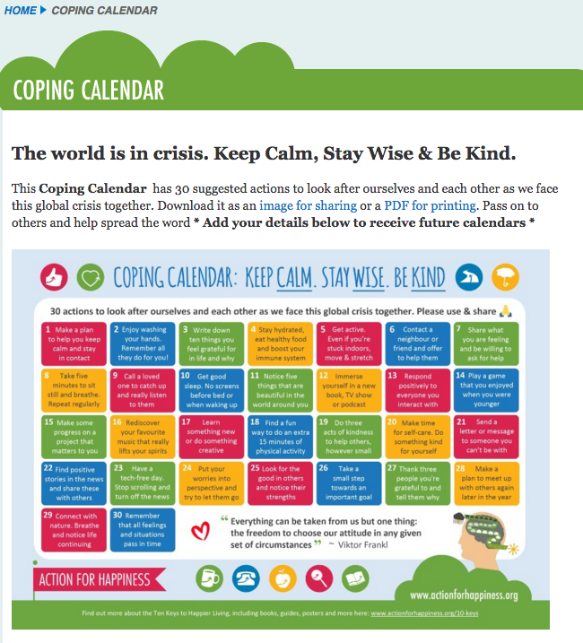

Intellectual Well:

Highland Digital School Hub

First News Education

@litllelessons20



Glasgow Science Centre – 10 am science – on Twitter @gsc1 or Facebook

National Parent Forum of Scotland

For adults:

Future Learn – free online training

CALA e-learning

Highland TSI online learning

Creativity well:

Fun things to do with the kids when you’re social distancing

https://www.thebestideasforkids.com/craft-ideas-for-kids/

Play Scotland Messy and Creative Play

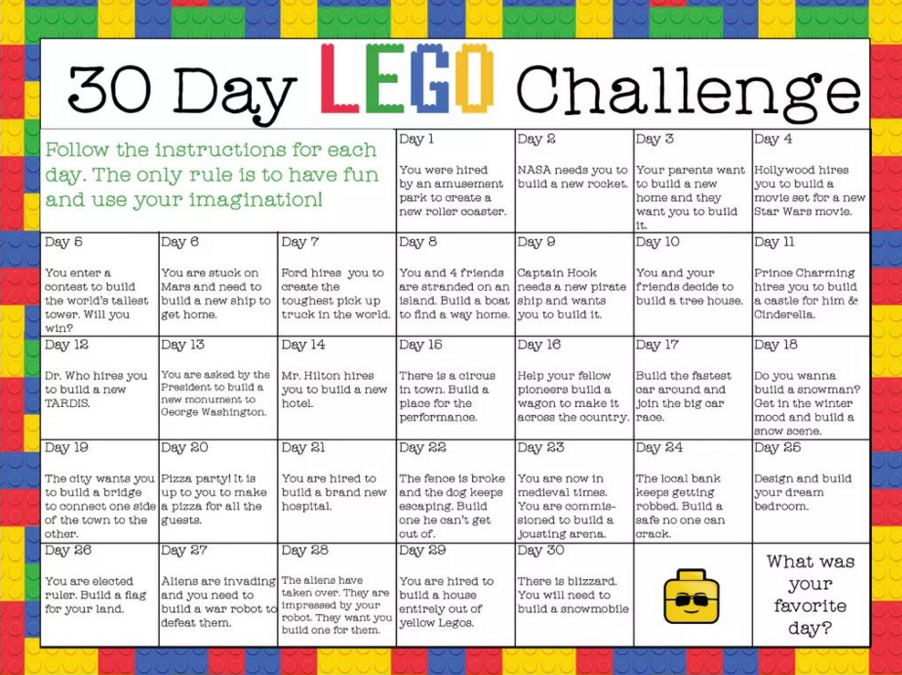

@beyondthebrick

Physical well:

I love these creative ways of exercising: https://m.facebook.com/groups/294941288150004/permalink/295142368129896/?d=m&vh=i

Exercise: there are plenty of exercise regimes and dance routines on You Tube.

If your children use Tik Tok maybe this is the time to choreograph some new dance moves.

Eat well, sleep well, keep moving, practice good hygiene, try to get fresh air – even at the window. That seems to be the advice.

Spiritual well:

Thankfulness is a really helpful antidote to all the negative news. An end of the day “reasons to be thankful” might help people have a counter to the negativity of news.

Space to be on your own for a time might be essential in a busy household. Finding and allocating a quiet space might work – otherwise expect people to be taking a long time in the loo!

