Highland Children and Young People’s Forum

March Bulletin

Highland Children and Young People’s Forum Response

The Forum is ceasing its direct face-to-face work with children and young people. The Forum’s Policy and Participation Leads continue to work from home and are available during their working hours by email or phone.

The Forum will remain in online communication with the young people we are currently working with to maintain relationships over the period of social distancing.

Policy Work

The Forum recognises that officers in The Highland Council (THC) and NHS Highland (NHSH) have many new priorities to be juggling just now, and normal policy review and development will be on hold until the emergency situation is on a more stable footing. However, the Policy Lead will continue, as soon as appropriate, to pursue the following policy issues:

UNCRC Children’s Rights: THC is due to produce a report about the steps they have taken to secure and improve children’s rights. Article 12 is quite clear about listening to children and young people about decisions that affect them. The Forum will be asking about the involvement of children and young people in evaluating their experience of rights for this report.

The Leadership Group and Improvement Groups that sat under it are no longer functional under the new Highland Council administration. It is not clear how partner agencies or children and young people will be involved in the development of the following:
- For Highland’s Children 5 Service Plan
- Highland Practice Model review
- Child’s Plan review
- Allocation model (for additional support for learning resources)

The Forum remains concerned about the governance, role and remit of the Joint Transitions Team. The Forum supported two young people with complex needs to present to relevant committees on the development of the team, which is not functioning as proposed and agreed at those meetings.

The Forum continues to ensure young voices are heard and involved in the new Education Improvement Team’s work in delivering the Transformational Change Programme.

Other issues raised by young people in our consultation and participation work are on going.

Participation Work

While face-to face work with young people is under suspension, work on promoting participation of children and young people with additional support needs will continue.

The Young Ambassadors for Inclusion programme of involving children and young people had to be cut short before the current round of participation had been completed. However, work to develop a draft framework for ambassadors for next year will continue during current home working.

The two young people involved in the National Programme made their second trip to Edinburgh before the new measures came into place.

Inspire Highland young people have been involved in delivering inclusion awareness training to school teachers and college lecturers.

A group of organisations representing people with a range of hidden disability needs have been meeting to enable young people and others with hidden disability to develop awareness raising training for bus drivers. This project will need to wait until social distancing is lifted before moving forward.

A second Youth Action Success meeting was held before the social distancing rules were in place.

“Covid-19” Social Distancing and Unintended Consequences

Hans Rosling, was a Professor of Global Health and as a statistician he played a key part in controlling the Ebola outbreak. It is a loss to the world that he is not still around to look at the data about Coronavirus. In his book “Factfulness”, a very good read in such challenging times, he speaks about the importance of changing the behaviour of people in terms of hygiene and social contact in tackling the Ebola outbreak, and the importance of good data in knowing when and how to do that.

The current escalation in social distancing is crucial to protect those in our families and communities who are vulnerable to this disease, including children, young people or parents with complex needs or long-term conditions.

Rosling also spoke about the potential of unintended consequences when cross-population decisions are taken. Social distancing may also have a negative social or economic impact on children, young people and families with other vulnerabilities.

This is a time when community really matters. There are things we can do as individuals and as third sector organisations to behave in such a way as to reduce the risk to those who are vulnerable whatever their vulnerabilities.

Other Vulnerabilities to Think about

Socially Vulnerable:
Unpaid carers are likely to have an increased role in providing protection and care to their loved ones.

Young carers may end up with much greater caring responsibilities for parents or other family members with long-term conditions, as other carers self-isolate or otherwise withdraw.

Parent carers of children with long-term conditions may struggle if their children are not accessing school and need to be at home for a prolonged period of time.

Children and young people with mental health issues may be particularly vulnerable to social isolation and the increased anxiety of the current situation as presented on media.

Staying at home will not reduce your vulnerability if home is not a safe place to be. Some young people live in homes where violence or other forms of abuse occur, particularly in times of heightened stress and pressure.

Children and young people with neurodiversity, such as Autistic Syndrome Disorder, will find the regular changes in routine and rituals difficult to manage.

Actions that can be taken:
- Keep in touch with vulnerable families and young people known to you by phone, online face-to-face or other means.
- Many local communities are offering delivery of anything people might need if they there are in social isolation.
- Please see resources and ideas below for helping children and young people stay mentally well and occupied.
- If you know a child or young person is vulnerable, do you have a safe way of communicating to check up on how they are doing?
- CHIP+ and National Autistic Society still have information officers available by phone or email.
- Resources to help people while at home are available on links below.

Financially Vulnerable:

Families living on the breadline are unlikely to have savings to buffer them through a period of unpaid leave or loss of hours on zero hours contracts.

The issue of holiday hunger for children on free school meals is sadly now a reality in our communities.

Actions that can be taken:

Information about benefits families may be found on the Citizen’s Advice Bureau website.

As families stockpile and struggle to find all the store cupboard necessities for a long time of isolation, food banks suffer.

Katy Kitchingham, Highlands and Islands Foodbank Network Area Manager suggests:

- Donate cash Blytheswood Food bank donation page
- Check with the food bank as to what food items are needed and either deliver in person if still possible or arrange with the centre to have delivered - contact details on Blytheswood website
- Consider volunteering...food banks will need healthy, younger volunteers over the next few weeks as the centres across the Highlands adjust to the social distancing recommendations.
- Campaign to end the 5week wait for Universal Credit.

Resilience and Wellbeing

Jenny Mosley The Five Wells of Wellbeing

Jenny Mosley has developed the “Five Wells of Wellbeing” with activities for chlidren.


In the absence of a normal routine, developing a routine to include each of these “wells” might be helpful to our children’s wellbeing in this extraordinary time. I suspect the same is true for the rest of us.

Intellectual well: Keep reading, keep learning
There is so much online learning available. Children can keep up to date with learning online and it might be an opportunity for adults to up-skill or learn something new from online training too.

Emotional well: have fun, play, enjoy time with loved ones.
In our busy lives, how often do we take the time to be fully present with loved ones? Social distancing will ironically give us more time to spend with families at home and to keep in touch with others via phone/IT.

Spiritual well: time for contemplation.
Keep a journal; meditate; read; connect with others and seek understanding of their stories; renew a sense of awe; seek a sense of hope; focus on reasons to be grateful and if you have faith pray and seek to draw strength and compassion from your faith.

Physical well: keep active.
Find enjoyable ways to exercise within confines of your space. Get fresh air even if it is only at a window. Eat healthily. Keep a routine and try to sleep well.

Creative well: Enjoy hobbies and explore interests.
If you are like me, you will have a list of projects you would love to do but never find the time for. Well, now is the time.
Have you fancied trying out making your own sour dough bread? Do you have space (even a window box) to start growing your own herbs or vegetables? Pinterest abounds with ideas to try.

Ten Tips for Self-isolating, home-working lone-parents (and others)

Just ideas- they might not work for you

1. Split your day into 2 hour chunks – alternate work and playful interaction
2. Put at least one of your 2 hour work slots when child/ren asleep - get up early and you could maybe do two.
3. Keep playing – enjoy the enforced time with your child/ren – in your two hour interaction slots make sure you are 100% there with your child/ren in their world of play. It will provide really precious memories of an otherwise difficult time.
4. Keep creating - art, craft, model making, story making, music making – you could order supplies online and start clay figures, a collage for the bedroom, family photo mosaic, good old Lego, teach your child to knit – set them up to do something absorbing for one of your daily work slots.
5. Keep learning - let your child choose a project they are interested in – and set an assignment for one of your work slots each day to find out more about it and teach you
6. Keep helping – in one of your work slots can your child/ren look at food items in the kitchen and find a recipe for using them? Draw up a schedule for how to spend your days together? Reorganise a shelf/cupboard?
7. Keep active and keep fit – together - make up a dance routine or plan some other exercise that fits with your interests and space.
8. Keep imagining – maybe pretend with your child/ren the reason for isolation is all sorts of things – left on a desert island, zombie attack, a “through the wardrobe” excursion to another land – enjoy stepping into an imaginary world.
9. Keep reading – depending on age and stage choose something long and exciting – Harry Potter; Famous Five; Narnia; you get the gist – and read out loud to each other.
10. Keep watching – a film a day is not a bad thing – choose good films – maybe old films your child might not have seen - and that will give you a two hour work slot.

Resource Links

The incredible variety of good ideas people are sharing online to help get through this period of confinement is an astounding testimony to people’s creativity and generosity. Keep an eye on Twitter and social media for many other ideas.

To maintain your wellbeing – fill up your “wells” with some of these.

Emotional well:

Emergency Planning for Carers

Dealing with conflict at home

@YoungMindsUK advice

Coping calendar

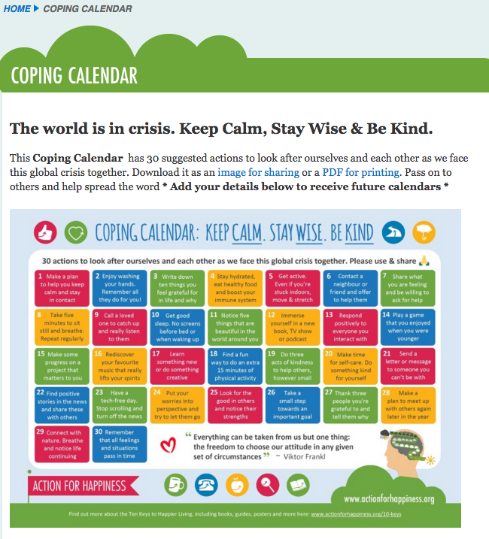

Intellectual Well:

Highland Digital School Hub

First News Education

@litllelessons20



Glasgow Science Centre – 10 am science – on Twitter @gsc1 or Facebook

National Parent Forum of Scotland

For adults:

Future Learn – free online training

CALA e-learning

Highland TSI online learning

Creativity well:

Fun things to do with the kids when you’re social distancing

https://www.thebestideasforkids.com/craft-ideas-for-kids/

Play Scotland Messy and Creative Play

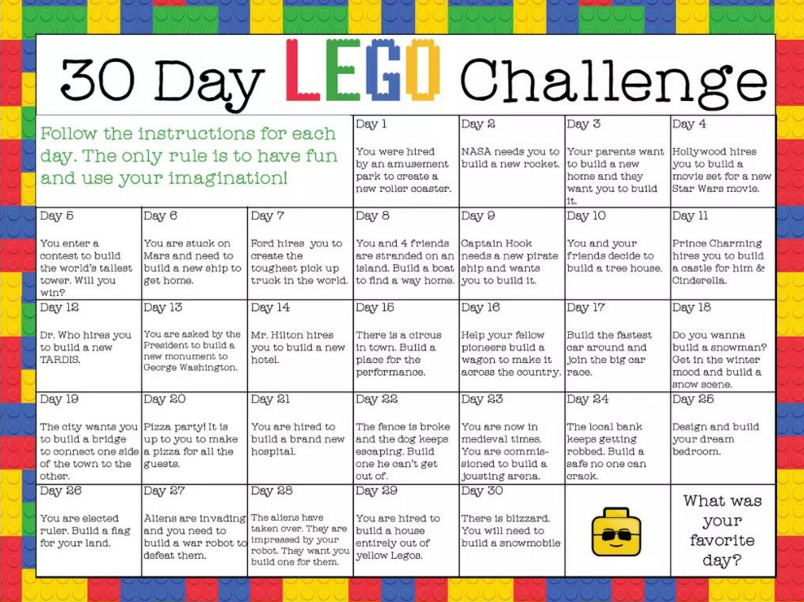

@beyondthebrick

Physical well:

I love these creative ways of exercising: https://m.facebook.com/groups/294941288150004/permalink/295142368129896/?d=m&vh=i

Exercise: there are plenty of exercise regimes and dance routines on You Tube.

If your children use Tik Tok maybe this is the time to choreograph some new dance moves.

Eat well, sleep well, keep moving, practice good hygiene, try to get fresh air – even at the window. That seems to be the advice.

Spiritual well:

Thankfulness is a really helpful antidote to all the negative news. An end of the day “reasons to be thankful” might help people have a counter to the negativity of news.

Space to be on your own for a time might be essential in a busy household. Finding and allocating a quiet space might work – otherwise expect people to be taking a long time in the loo!

