Useful resources for children & young people and those who work alongside them.
- Time Space Compassion- This is an introductory guide for practitioners, and anyone who works with people, to help manage periods of suicidal crisis. Time Space Compassion is based on the principles of trauma-informed practice and human rights-based approach to supporting individuals experiencing suicidal thoughts and behaviours. This has been created as part of Scotland’s Suicide Prevention Strategy and Action Plan. More information and the guide itself can be found here.

- Mindful range Primark- The company ‘Haico’ has created a stationary range called ‘Mindful’, which has been designed for people with autism or sensory processing disorder (SPD). This range includes interactive ‘popping’ notebooks, squishy pens, ‘knobbly’ fidget toys and more. They will be donating 20% of profits from this line to the National Autistic Society, which is expected to be around £20,000.

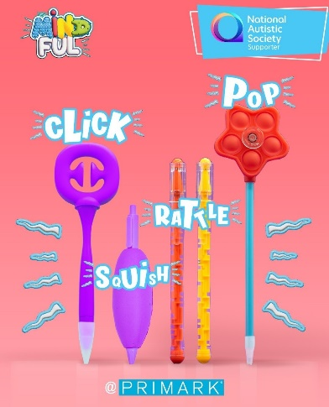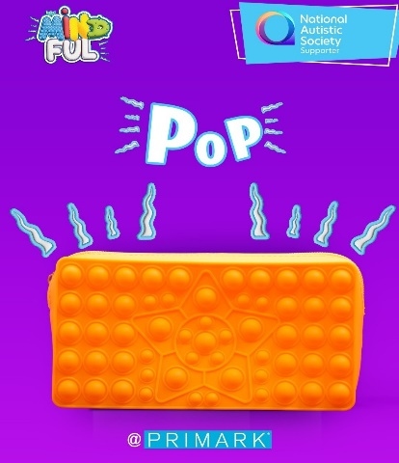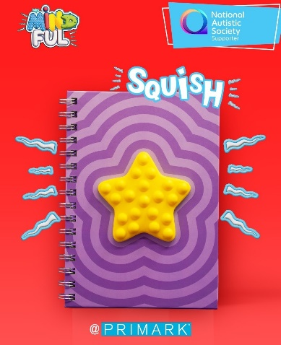

- SafeKab App and SafeWalk Service- The company SafeKab has recently partnered with Inverness Taxis to try and improve safety within Inverness and the surrounding area. SafeKab is an app that has location and safety features for passengers and drivers to use within taxis. This enables a person’s location to be shared with a trusted contact, codes to be used so that a passenger gets into the correct vehicle, an alert (panic) button and many more features. SafeWalk is a service that can be found within the SafeKab app. This enables a person to enter the location that they are walking to and to share their current location with a trusted contact. There is an alert button which will share the user’s location with SafeKab and their trusted contact if they feel that they are in danger. This seems like an app that would be particularly useful for keeping children and young people safe in the Inverness region, and therefore seems important to share information on- more of which can be found here.

- Resources from the It Takes All Kinds of Minds (ITAKOM) Conference 2023

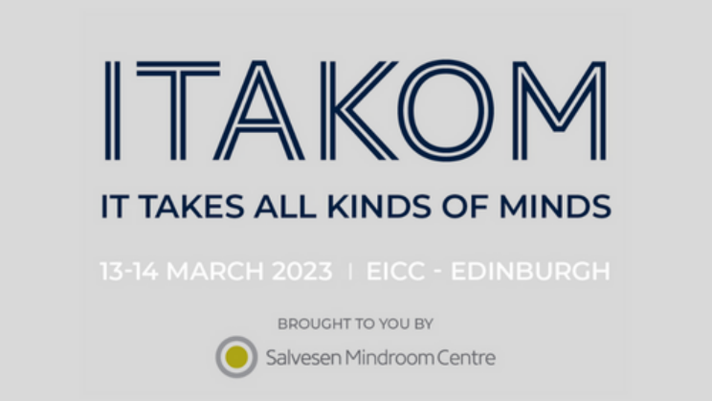

- Procrastination station- This is a hub with information, resources and courses which have been designed for adults with ADHD in Scotland. There is coaching, mindfulness, research articles, and tips for living with- and raising awareness of- adults living with ADHD. Although this wouldn’t necessarily be relevant to all young people, those in the 18-25 age bracket could benefit from this website, and the resources could potentially help all age ranges.

- EPIC Think Learn- Edinburgh Psychoeducation Intervention for Children and young people (EPIC) has programmes, toolkits and resources for parents and teachers “to empower and upskill neurodivergent children and young people”. EPIC has activities that can help identify a young person’s strengths and difficulties associated with being neurodivergent, and supports children by providing strategies to manage any struggles. This has been co-produced with children and young people, teachers and parents, and their services currently include: webinars/seminars, consultancy and workshops. Their website can be found here.

- Scottish Autism Website- Scottish Autism is a charity that aims to help autistic people in Scotland be healthy, happy and fulfilled in life. They have lots of support services and resources on their website, including an autism advice line (open 10am-4pm Tuesday to Friday) and thematic online support groups (e.g. art, mindfulness, choir, generic support etc.).

- Salvesen Mindroom Supporting Children and Young People with Learning Difficulties Essential Rights booklet- This outlines relevant legislation, topics of support and useful organisation’s contacts in relation to the rights of children and young people with learning disabilities. You can access the booklet as a pdf here.

- The Umbrella Gang comics- The ADHD foundation, along with Dekko Comics, has created 3 volumes of comics called ‘The Umbrella Gang’, which includes characters that represent different forms of neurodiversity. These comics can be used to help young people understand what they or their peers might be going through and help them learn more about the different types of neurodiversity. You can download the comics digitally here: The Umbrella Gang Comics - ADHD Foundation : ADHD Foundation
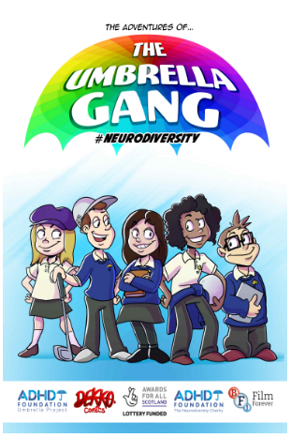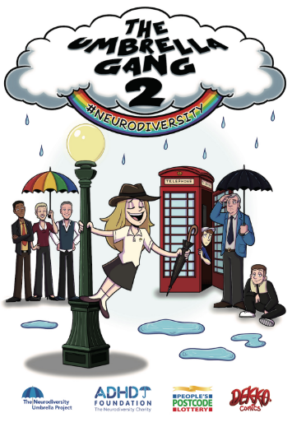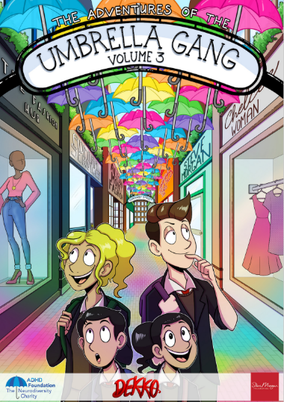

- Zoteria app- Zoteria is an LGBTQ+ hate-crime reporting app, which has been created by Vodafone Foundation, Stonewall and Galop. Their site states that many hate crimes against members of the LGBTQ+ community go unreported due to thoughts that nothing will be done and fear or distrust of the police. This app is free, enables the user to report an incident through a form and then receive support from Galop (an anti-abuse charity for LGBTQ+ people). It is not linked with the police and users are advised to call 999 if under threat. You can find out more about the app and download it here.

- Child and Adolescent Mental Health Service downloadable resources- CAMHS has a section on their website dedicated to resources associated with mental health, neurodiversity and neurological conditions. These are mostly support guides, either for parents/carers or for the individual. They can be found and downloaded here.

